Sample R Markdown

Dr Vinod

7 July 2017

**Introduction**

This is a sample document for demonstrating R Markdown command.

library(readr)  
slr <- read_csv("C:/Users/inurture1/Desktop/slr.csv")

**R Codes for knowing the data**

dim(slr)

## [1] 12 3

The data set slr.csv was having 3 variables and 12 observations

Through structure, we found that all variables were integer type

str(slr)

## Classes 'tbl_df', 'tbl' and 'data.frame': 12 obs. of 3 variables:  
## $ Observation no: int 1 2 3 4 5 6 7 8 9 10 ...  
## $ Advt : int 92 94 97 98 100 102 104 105 105 107 ...  
## $ Sales : int 930 900 1020 990 1100 1050 1150 1120 1130 1200 ...

Summary command had given us basic descriptive statistics of variables, Advertisement and Sales.

summary(slr)

## Observation no Advt Sales   
## Min. : 1.00 Min. : 92.00 Min. : 900   
## 1st Qu.: 3.75 1st Qu.: 97.75 1st Qu.:1012   
## Median : 6.50 Median :103.00 Median :1110   
## Mean : 6.50 Mean :101.75 Mean :1088   
## 3rd Qu.: 9.25 3rd Qu.:105.50 3rd Qu.:1162   
## Max. :12.00 Max. :110.00 Max. :1250

We had plotted histograms of Sales and Advertisement for examining the distribution.

hist(slr$Sales, col = "red")

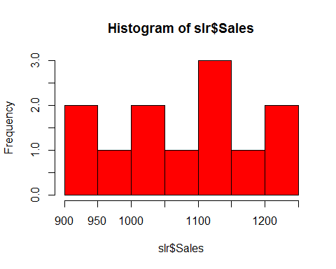

hist(slr$Advt, col = "blue")

